Handout 1.3: SLO Template Checklist
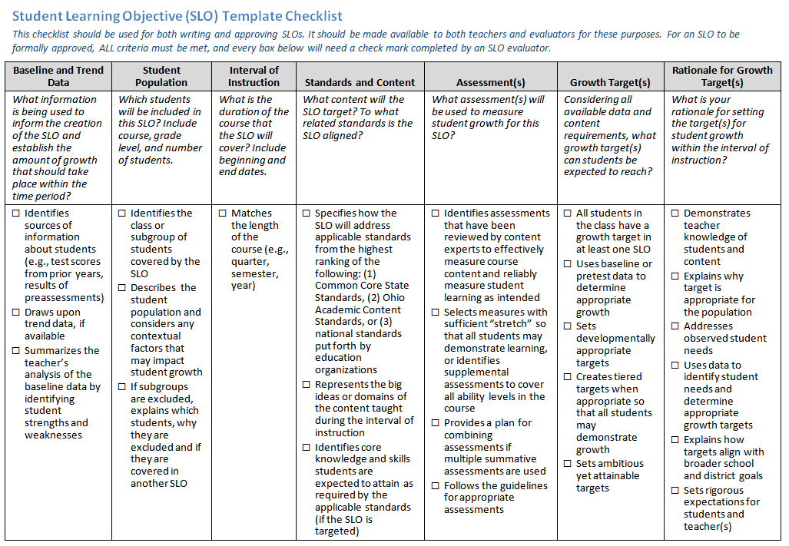

Handout 1.6: Sample SLO Approval Status and Accompanying Rationale
Name: ____________________________________ SLO Team (Teachers’ Names): ___________________________
Subject: ___________________________________ Grade: _________

Based on the administrator’s review, the SLO approval status is:
□ Approved
The SLO has met the criteria and expectations outlined in the SLO guidance checklist.
As a result:
- The teacher(s) have focused on the “right” goals.
- The SLO covers the course content and identifies the students who truly need to improve.
- The SLO is logically related to improved student learning.
- The SLO is leading to more equality of educational opportunities for all students.
- The SLO does not lead to unintended consequences, such as the curriculum becoming unacceptably narrowed.

□ Not Approved
The SLO does not meet the criteria and expectations outlined in the SLO guidance
checklist. The SLO requires further development in the areas listed below. Once the
outstanding areas are sufficiently addressed, the SLO will be approved. Areas requiring further development:
_____ Baseline and Trend Data | _____ Assessment(s)
_____ Student Population | _____ Growth Target(s)
_____ Interval of Instruction | _____ Rationale for Growth Target(s)
_____ Standards and Content

Administrator’s Signature and Date: _______________________________
Teacher’s Signature and Date: ____________________________________

